***East West University***

**Software requirement Specification(SRS) Report with UML Use Case, Class Diagram, Sequence Diagram, Activity Diagram, and ER Diagram**

**Course Title : Software Engineering and Information System Design**

**Course Code :** CSE 411

**Section :** 03

**Project topic: Online Ambulance Service**

**Submitted To**

**Md. Mohsin Uddin**

Lecturer,

Department of Computer Science and Engineering

**Submitted By**

**Mohammad Mehedi Hasan**

2017-1-60-085

**Md. Jubayer Hossain Abir**

2017-1-60-084

**Submission Date**

24/09/2020

**Introduction**:

This is an integrated service that provides all information about the location of the ambulance and its routes for the public. The proposed system is a web-based application that provides information regarding ambulance quality, timings, routes, fair. The system contains an online order system where service recipients can order any nearby ambulance service and service providers can receive the given order. There is also an admin module where admin can add ambulance, scrap ambulance, and also any update. The admin is a panel that will be consisted of a group of authorized persons.

**Problem Definition:**

1. There are several problems in Bangladesh to manage the ambulance service at the proper time.
2. Sometimes ambulances’ fairs are taken much higher than normal fair.
3. Syndicates try to control ambulance service which should be vanished.
4. There is a lack of ambulances in Bangladesh.

**Challenges:**

1. This system will be user friendly and reliable to the customers.
2. The security system of the database will be made stronger so that nobody can get any information illegally.
3. A few features will be added here so that either ambulance’ owner or customer can’t be harassed.
4. Information can be collected, processed, and communicated more quickly and efficiently. The system ensures that the right information reaches the right person at the right time.
5. Provide accurate information to the user for taking necessary decisions.

**Motivation:**

The proposed system is designed to eradicate some inconveniences of the owner of ambulances and customers usually they face. The customers will easily be able to find out any ambulance at the right moment by using this system. Sometimes patients die due to the lack of ambulance when they need it.

1. Service recipients can registrar here to get service from the site.
2. Service recipients can order any ambulance service through the site.
3. Service recipients can log in and use the home page to order for service.
4. Service recipients can view his/her nearby ambulance locations.
5. Service recipients can also view the details and the route map of the ambulance.
6. There will be a service provider page where they can manage their logs.
7. There will be an admin login page where admin can provide service as per the request of the user.

**System Components:**

Fig. Home Module

Fig. Inbox Module

Fig. History Module

Fig. Profile Module

Fig. Service Provider Module

Fig. Admin Module

**System requirements:**

**Non-functional requirements:**

**Efficiency requirement:** The implementation of this online ambulance service would save a lot of time for the person in need. The system is efficient in every aspect from better payment service to viewing the updated location of the ambulance.

**Reliability requirement:** The system is reliable in the sense that it will show the accurate distance of the nearby ambulance and would not waste any precious time of the service recipient and the routes can be selected by the recipient itself. The payment method is very safe and the recipient can through the profile of service providers for safety issues.

**Availability requirement:** The system is 24 hours active and the service recipients can call for an ambulance at any time.

**Usability requirement:** The system design is user friendly and users like service recipients, service rider, and admin could use the service with ease.

**Proximity Requirement:** The system design is based on giving proper service to the service recipients by providing seamless communication. Any user can contact at any given time and will get the service required by using the inbox page.

**Functional requirements:**

* **Login:** The system will provide users with a login option. No user will be able to enter the system without proper authentication. Because given data will be compared with data stored from the system database.
* **Forget Password:** If a user forgets his/her password then they can click in the forgot password option. A few questions will be asked to the user and if the information is correct then the user will be asked to enter a new password.
* **Registration:** Before login one must registrar his/her information in the database of this system. Two registration options will be given below for the user so that he/she can choose if he/she wants to register as a provider or a recipient. On the registration page, the user will have to input a name, mail, phone number, etc.
* **Email Functionality:** The system must be able to send emails to the service recipients and service providers after service completion. Even if registration is complete a mail will be sent to the user confirming his/her registration.
* **Storing New Information:** The system must be able to store new information. Even the service recipient and service provider will be able to create his/her profile by storing information like name, phone number, email, etc. Information like display pictures, portfolios, etc. will be stored in a directory.
* **Show History:** The system must be able to show history to service recipients from any level. Users will be to see the exact time and date of the previous usage. History will also show the source to destination, service provider profile, etc. to the service recipient and service provider.
* **Providing User id:** User id will be given to users like service recipients and service providers. User id will be unique and it will be created by merging the user’s last name and a unique number which will also tell the user his/her serial number as a user of this system.
* **Transaction History:** The system must be able to show the service recipients' transaction history. The transaction history will be kept in the history option.
* **Logout:** The user must be able to logout after they had finished taking their service. The logout system is part of the log module.
* **Processing Database:** The system must be able to process information from the database. Queries will be run to create a relationship between tables and attributes. Relationships like one to one, one to many relations will be used here.
* **Select Route and Check Nearby Ambulance:** The system will allow the service recipients to check the nearby ambulance and select the route by themselves. As the mapping service will be integrated into the system, the service recipient can see all possible routes from source to destination and find out the optimal path.
* **Service to the Admin:** The system must allow admin to enhance the map, update fair details, check complaint box and messages, add new admins, check service providers list, and delete any data or feature required. Admin will be able to add new locations and places in the mapping system. The complaint box will be kept protected. For example, if a service provider wants to complain about the misbehavior of a service provider, that complaint will be kept protected from the service provider and the same kind of protection goes for the service recipient.
* **Verifying before Approving:** Before taking any service system will allow the service recipient to check the history of service providers.
* **Payment System:** In the profile option, there would be an option called a digital payment system which will keep a record of the digital wallet. Other than digital payment, regular cash option can also be found in the payment module.
* **Edit Information:** The system will allow the service recipients and service providers to edit any information by going on their profile and using the setting option. In the setting option, they can change their user name, password, email, etc. In settings, they can also deactivate their id and thus shutting down the profile.
* **Complaint Box:** The system must also allow admin to reply to the complaints sent by the user. Complaint box will be kept protected from two main user provider and recipient. But admin will have to access all those complaints.
* **Authorization:** The system should be designed in such a way that a non-authorized person can’t access the service. No one can enter into the system without a username and id, not even admin. All of the user name and password will be saved in the database.
* **Record Modification:** The records should be modified by only administrators and no one else. Admin can delete any user profile if needed.
* **Chat Option:** The system will provide service recipients and service providers to directly text with the administrator by chat option if system recipients are reluctant to use the complaint box. The text will be protected from providers and recipients. The chat option can be found in the inbox module.
* **Report Card:** There will be an option called a report card in the service provider panel. Information from the service rate will be dynamically added to the report card. By keeping the recipient information protected.

**System tools:** HTML, CSS, Python, Django, MySQL.

**UML** **Use Case Diagram 1:**

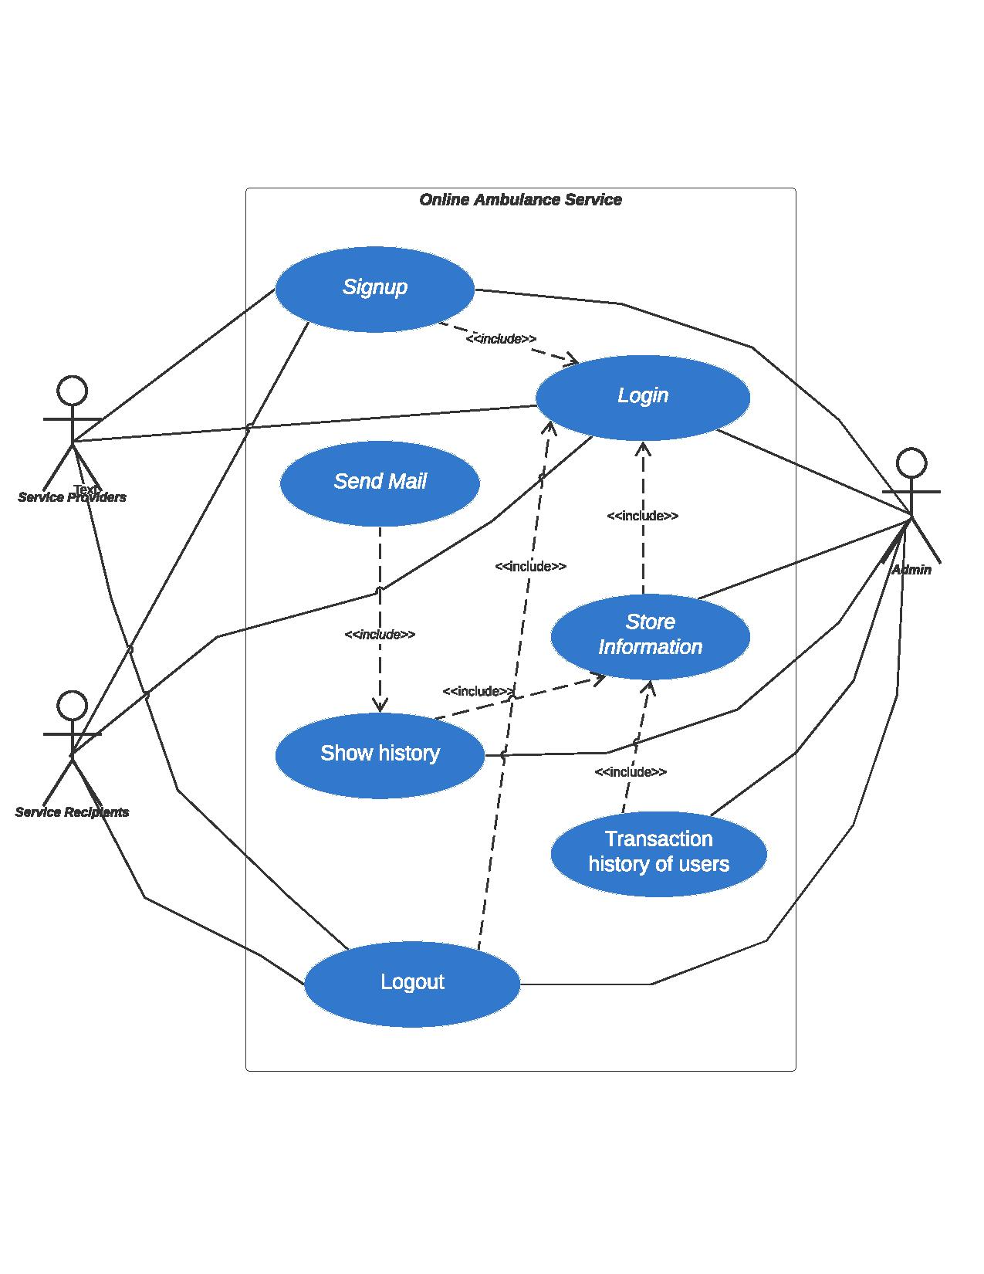

**UML Use Case Diagram 2:**

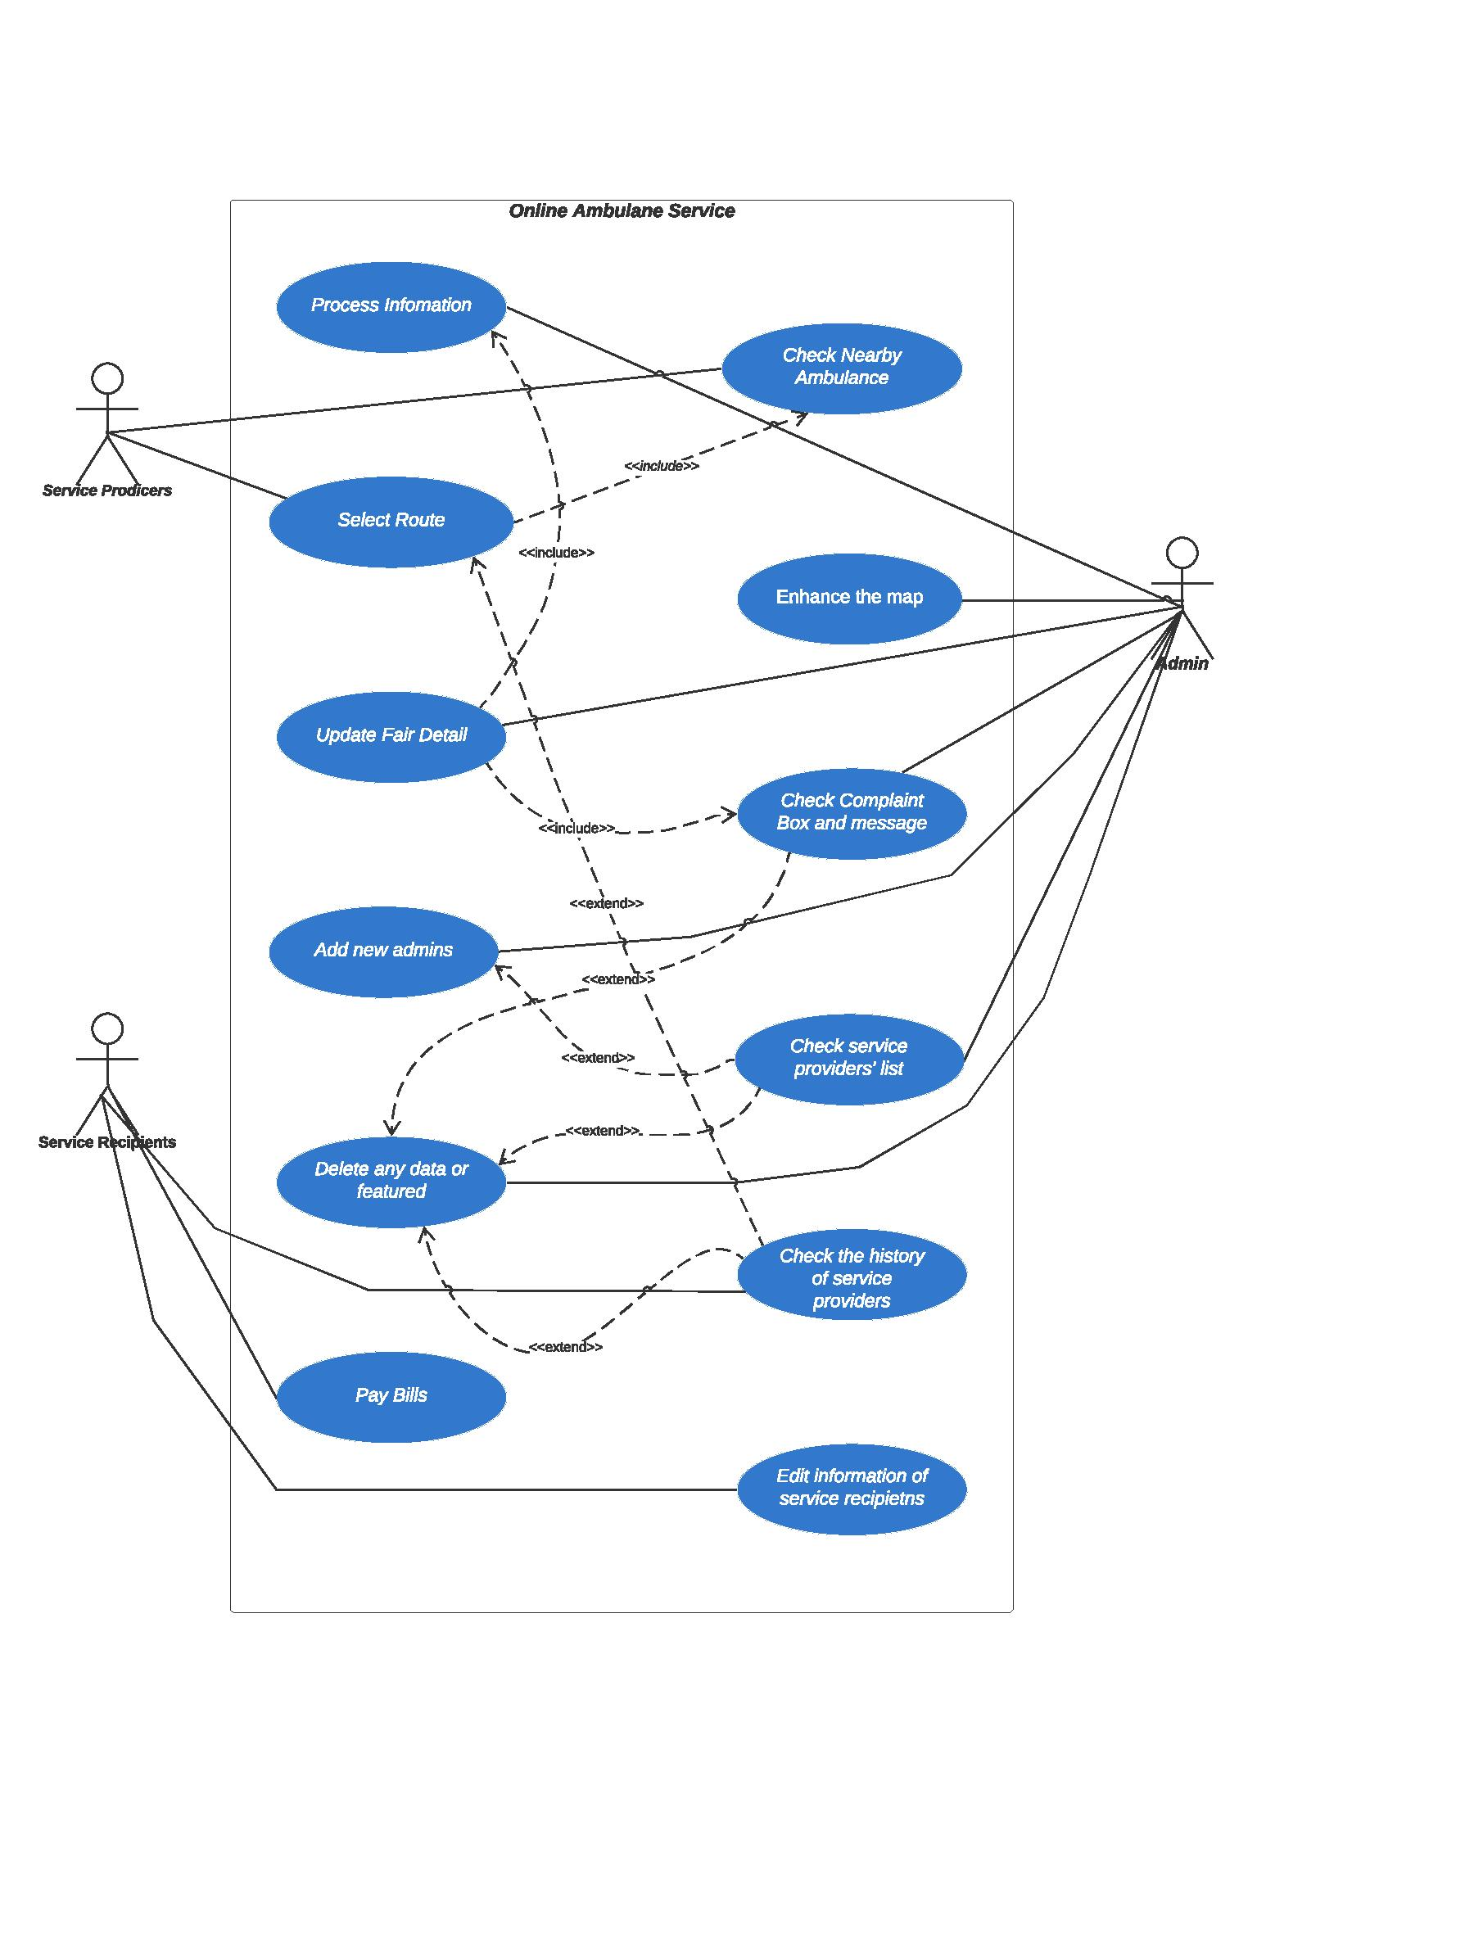

**UML Use Case Diagram 3:**

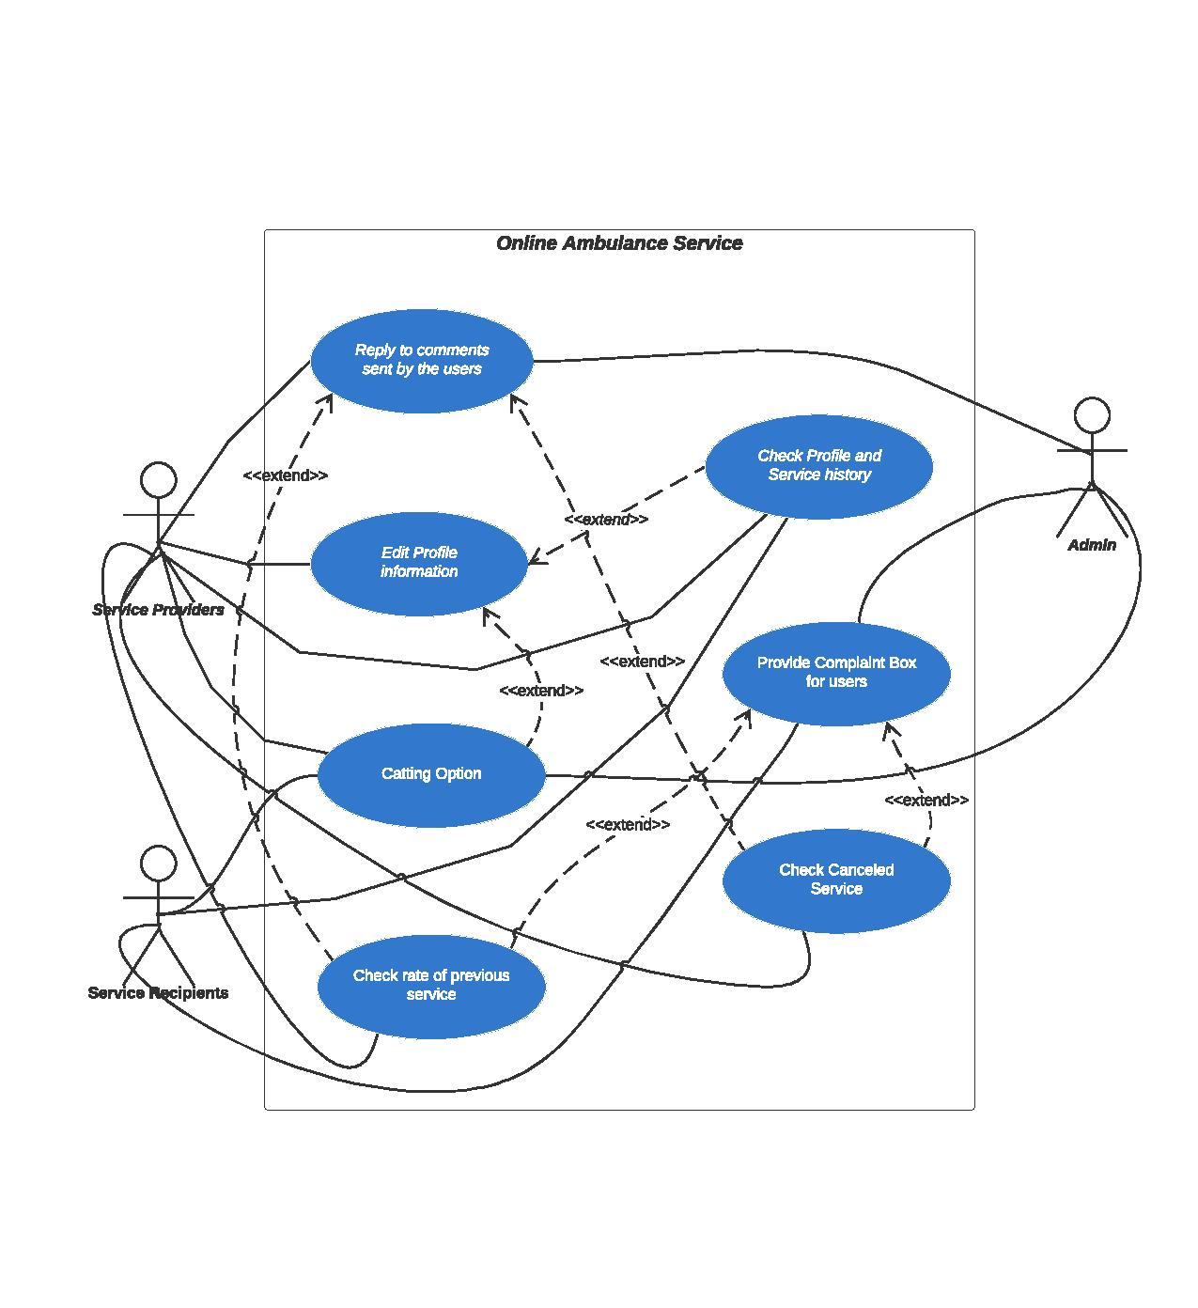

**UML Class Diagram:**

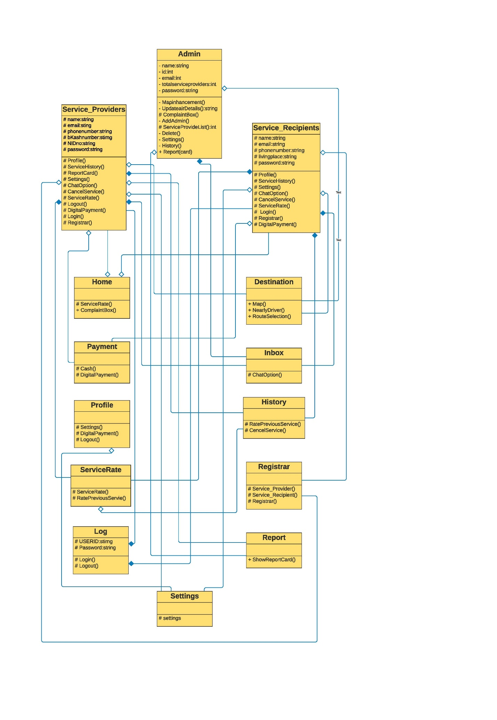

**Sequence Diagram:**

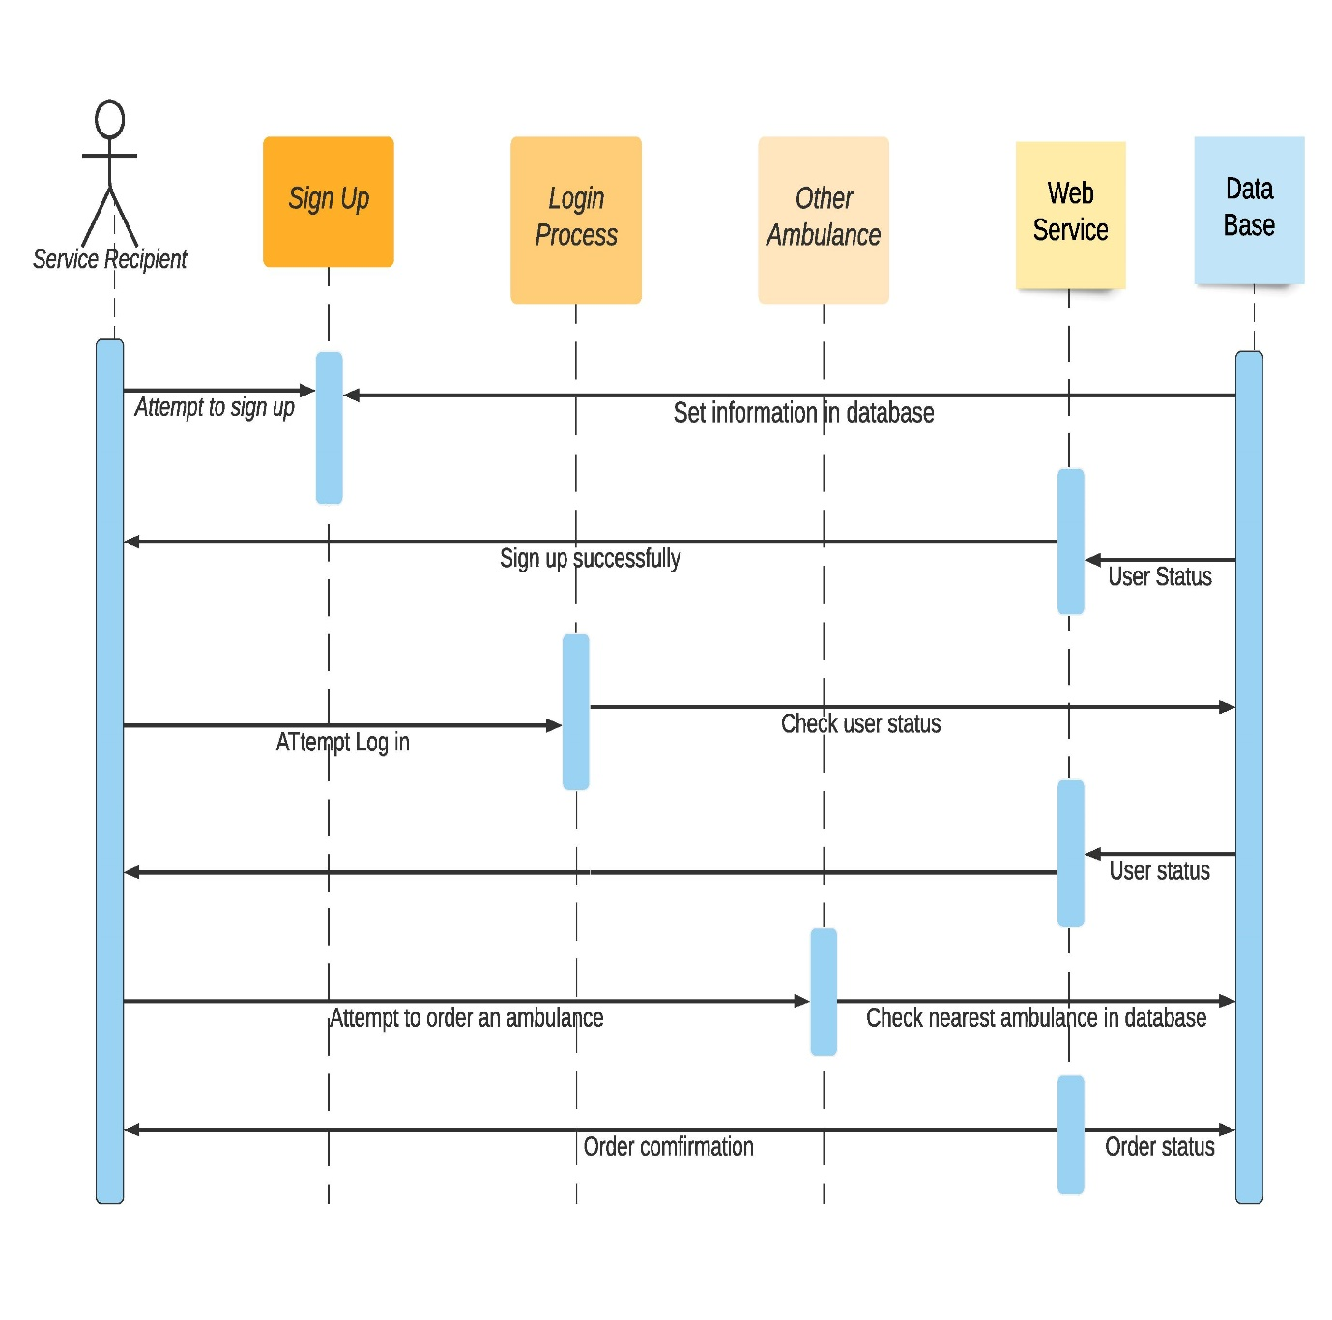

**Activity Diagram:**

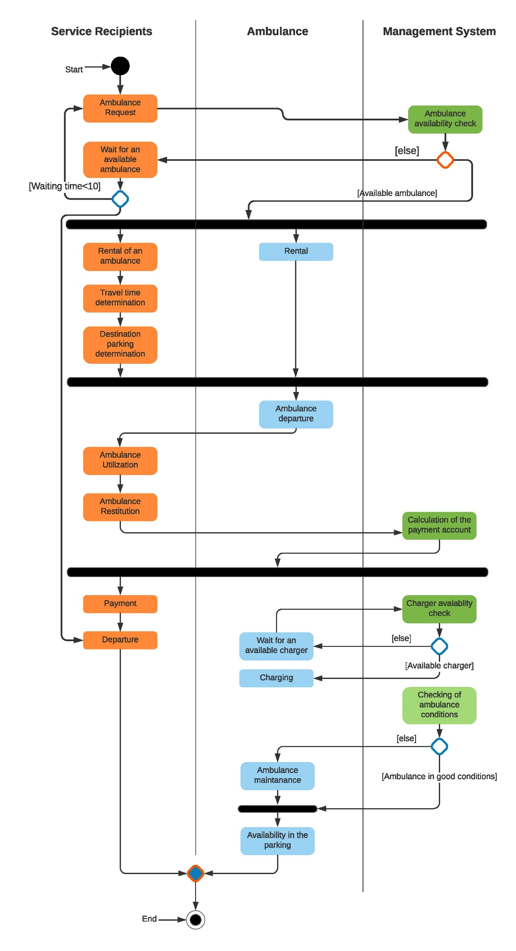

**ER Diagram:**

